EXPERIMENT 6:-

TO PERFORM GROUPING , ORDERING AND AGGREGATE FUNCTIONS .

1. **GROUP BY** :- The GROUP BY statement groups rows that have the same values into summary rows,

**SYNTAX:**- select column name from tablename

where condition group by column name**;**

**OUTPUT:-**

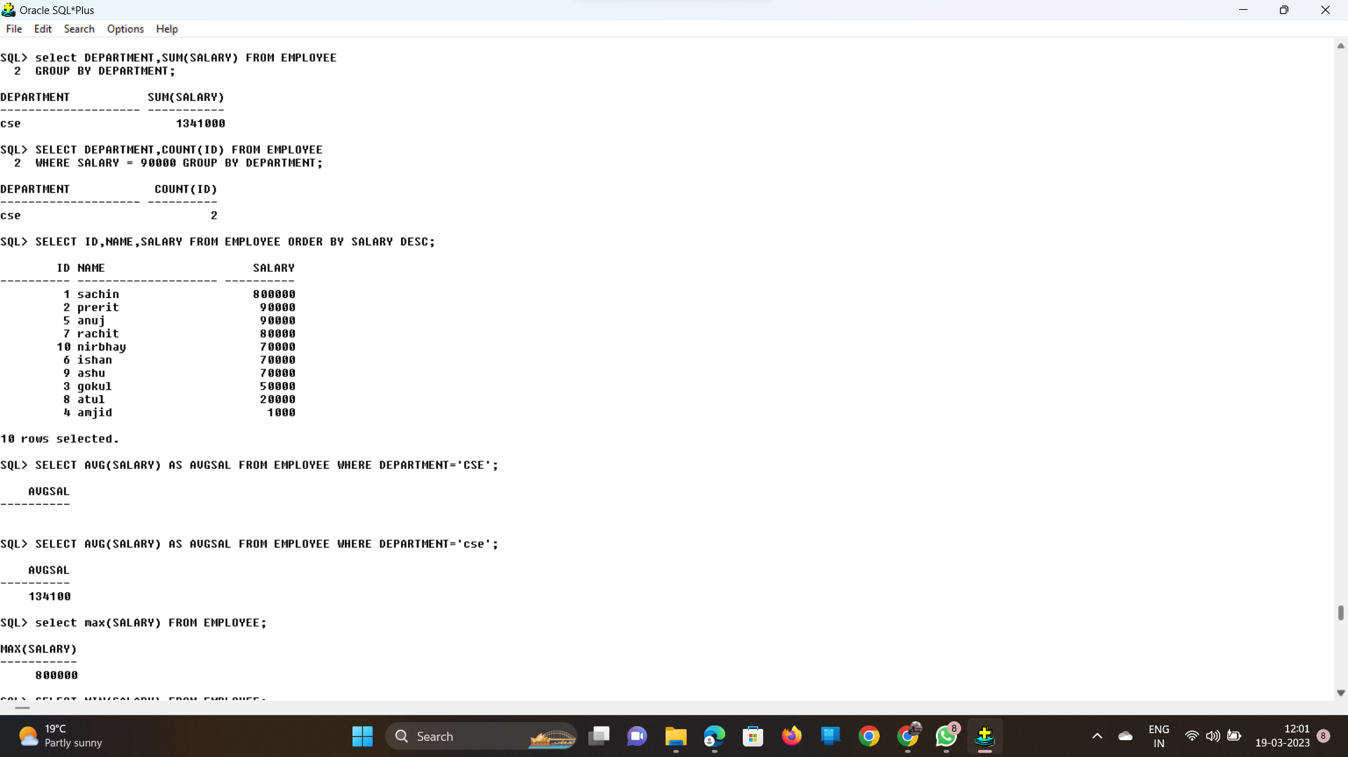

1. **ORDER BY**:- The ORDER BY keyword is used to sort the result-set in ascending or descending order. The ORDER BY keyword sorts the records in ascending order by default.

**SYNTAX:**- select id,name,salary from tablename order by salary desc;

**OUTPUT:-**



**AGGREGATE FUNCTIONS:**

Aggregate functions are used to perform operations across entire columns.

Aggregate Functions Are:-

1. AVERAGE:- The AVG() function returns the average value of a numeric column.

SYNTAX:- select AVG(SALARY) as AVGSAL from employee where DEPARTMENT=’cse’;

**OUTPUT:-**

1. **COUNT:-** The COUNT() function returns the number of rows that matches a specified criterion.

**SYNTAX:-** select DEPARTMENT ,COUNT(ID) FROM EMPLOYEE

WHERE SALARY=90000 GROUP BY DEPARTMENT

**OUTPUT:-**



**03.MINIMUM:-** The MIN function returns the minimum value in a set of values.

**SYNTAX**:- select min(salary) from employee;

**Output:**-

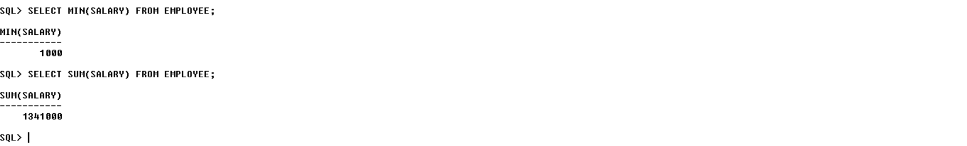

04 **MAXIMUM:** The MAX() function returns the largest value of the selected column.

**SYNTAX:-** select max(salary) from employee;

**Output:-**

05 **SUM:** The SQL SUM function is an aggregate function that is used to perform a calculation on a set of values.

SYNTAX:- select sum(salary) from employee;

Output:-

